RECIPE OF THE WEEK: 31/10/2022
Feta Saganaki me Meli ke Sousami
(Fried Feta with Honey and Sesame Seeds)

This is an amazing appetiser made with fried feta, sprinkled with sesame seeds and drizzled with Greek honey. This is an easy delicious traditional recipe which can be served as a starter or as part of a meze.

Ingredients
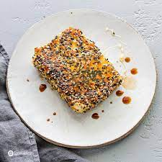
(Makes 2 pieces)
2 x 200g feta cheese
2 medium free-range eggs
100g plain flour
50g white sesame seeds
25g black sesame seeds
olive oil for frying

For serving
thyme-scented Greek honey

Method
1. Beat the eggs in a large bowl. Place the flour on one plate and the mixture of black and white sesame seeds on another.
2. Lightly cover the first block of feta with flour and shake to remove any excess. Next, immerse the feta in the egg mixture and finally cover with sesame seeds. Set aside on a plate.
3. Repeat this process with the second block of feta and place next to the first one.
4. Heat two tablespoons of olive oil in a pan over a medium-high heat and fry the feta blocks for two minutes on each side until they have a golden crust. Do not over-fry the feta cheese because the sesame seeds may become bitter.
5. Remove from the frying pan with a spatula and place on kitchen paper to absorb any excess oil. Drizzle with honey and serve immediately.
6. You may heat the feta in a pre-heated oven at 180⁰C/160⁰C/gas 4 for 13-15 minutes until golden.

© George Psarias

